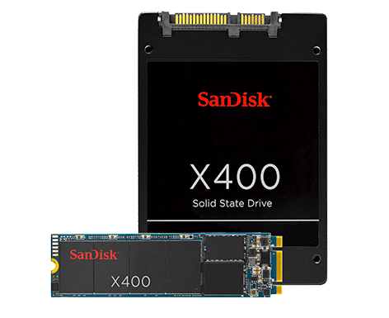

The drive offers up to 500/420 megabyte per second (MB/sec) 2 sequential read/write speeds, and enables a user to copy a 4GB high-definition movie in less than 10 seconds*. In addition to the standard 2.5 inch form factor, the X100 SSD also comes in mSATA and customized thin form factors to address the emerging ultra-thin laptop market. SanDisk offers a wide variety of configuration options, including standalone and dual drive caching solutions.

"With the introduction of the X100 SSD, SanDisk now offers OEMs a complete selection of SSD storage choices," said Kevin Conley, senior vice president and general manager, client storage solutions, SanDisk. "From the smallest BGA form factors of the iSSD to the economical lower power U100, all the way up to the high performance and high capacity points of our new X100, SanDisk offers a solution to meet the needs of notebook, desktop and ultra-thin laptop manufacturers."

|  |  |
| --- | --- |
| **Performance** | • Up to 500/420 MB/s sequential read/write speeds |
| **Capacity** | • 32GB, 64GB, 128GB, 256GB, 512GB |
| **Form Factor** | • Cased 2.5 inch 7mm or 9.5mm, mSATA and customized form factors |
| **Interface** | • SATA 6Gb/s |
| **Power Consumption** | • Active Power (Typical)**: 150mW (@ 3.3V) • Standby Mode (Typical)***: 75mW (@ 3.3V) |
| **Reliability** | • MTBF up to two million hours3 |
| **Target Platforms** | • Ultrabook, notebook, and desktop computers |